Medium of Performance. Part 3

Connecting medium of performance to performers
One other major aspect of medium of performance is to associate performers with a particular medium, e.g., performer 1 plays bass guitar; performer 2 plays drums. To do this requires connecting the bf:Contribution node with the bf:PerformedMedium node.
There are 2 properties which connect a bf:Contribution to medium of performance related classes, both of which have already been described in Parts 1 & 2 of this paper. The first of these is pmo:hasMediumOfPerformance, which directly connects bf:Contribution to pmo:MediumOfPerformance (or any of its subclasses):

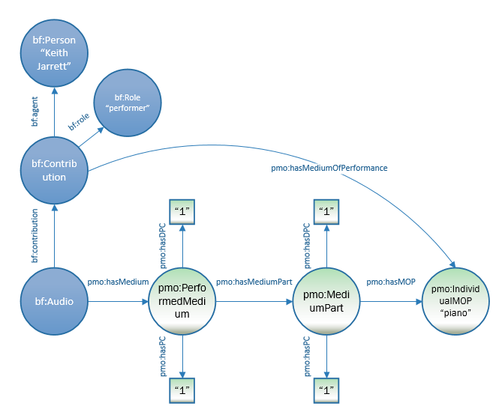

:a1 a bf:Audio ;
pmo:hasMedium [
a pmo:PerformedMedium ;
pmo:hasDistinctPartCount “1” ;
pmo:hasPerformerCount “1” ;
pmo:hasMediumPart [
a pmo:MediumPart ;
pmo:hasDistinctPartCount "1" ;
pmo:hasPerformerCount “1” ;
pmo:hasMediumOfPerformance <http://id.loc.gov/authorities/performanceMediums/mp2013015550>
] ;
] .
bf:contribution [
a bf:Contribution ;
bf:role <http://id.loc.gov/vocabulary/relators/prf> ;
bf:agent <http://id.loc.gov/rwo/agents/n81026503> ;
pmo:hasMediumOfPerformance <http://id.loc.gov/authorities/performanceMediums/mp2013015550> ;
] .

<http://id.loc.gov/vocabulary/relators/prf> a bf:Role ;
rdfs:label "performer" ;

<http://id.loc.gov/rwo/agents/n81026503> a bf:Person ;
rdfs:label "Jarrett, Keith" ;

<http://id.loc.gov/authorities/performanceMediums/mp2013015550> a pmo:IndividualMediumOfPerformance ;
rdfs:label “piano” .

The other is bf:hasMusicPart, which connects bf:Contribution directly to pmo:MusicPart. The diagram does not describe the entire medium; there would at least also be a Violin 2 part.

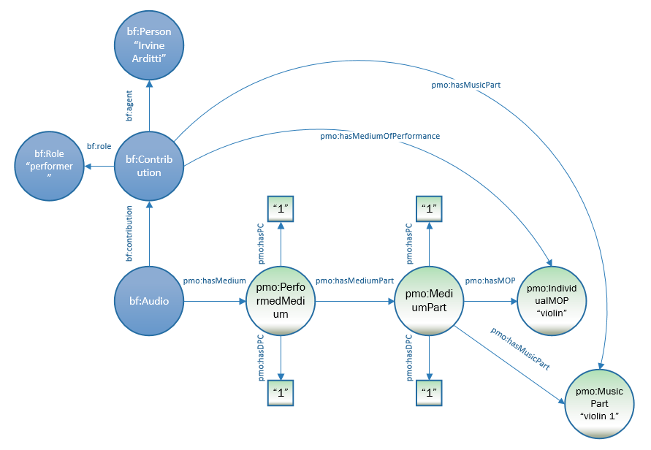

:a1 a bf:Audio ;
pmo:hasMedium [
a pmo:PerformedMedium ;
pmo:hasDistinctPartCount “2” ;
pmo:hasPerformerCount “2” ;
pmo:hasMediumPart [
a pmo:MediumPart ;
pmo:hasDistinctPartCount "2" ;
pmo:hasPerformerCount “2” ;
pmo:hasMediumOfPerformance <http://id.loc.gov/authorities/performanceMediums/mp2013015782> ;
pmo:hasMusicPart [
a pmo:Music Part ;
rdfs:label “Violin 1” ;
pmo:hasMusicPart [
a pmo:Music Part ;
rdfs:label “Violin 2” ;
] ;
] .
bf:contribution [
a bf:Contribution ;
bf:role <http://id.loc.gov/vocabulary/relators/prf> ;
bf:agent <http://id.loc.gov/authorities/names/n82155189> ;
pmo:hasMediumOfPerformance <http://id.loc.gov/authorities/performanceMediums/mp2013015782> ;
pmo:hasMusicPart [
a pmo:MusicPart ;
rdfs:label "Violin 1" ;
] .
bf:contribution [
a bf:Contribution ;
bf:role <http://id.loc.gov/vocabulary/relators/prf> ;
bf:agent < http://id.loc.gov/authorities/names/nr92005887> ;
pmo:hasMediumOfPerformance <http://id.loc.gov/authorities/performanceMediums/mp2013015782> ;
pmo:hasMusicPart [
a pmo:MusicPart ;
rdfs:label "Violin2" ;
] .

http://id.loc.gov/vocabulary/relators/prf a bf:Role ;
rdfs:label “performer” ;

<http://id.loc.gov/authorities/performanceMediums/mp2013015782> a pmo:IndividualMediumOfPerformance ;
rdfs:label “violin” .

<http://id.loc.gov/authorities/names/n82155189> a bf:Person ;
rdfs:label “Arditti, Irvine” .

The following diagram represents a string quartet, alternately represented as an ensemble (“string quartet”) and as individual performers (only violins 1 & 2 are given; in full there would also be a viola and a cello). The contributions include both a contribution from the ensemble as a whole, and from the individual performers, down to the music parts they perform. This is about as precise as one can get with this model:
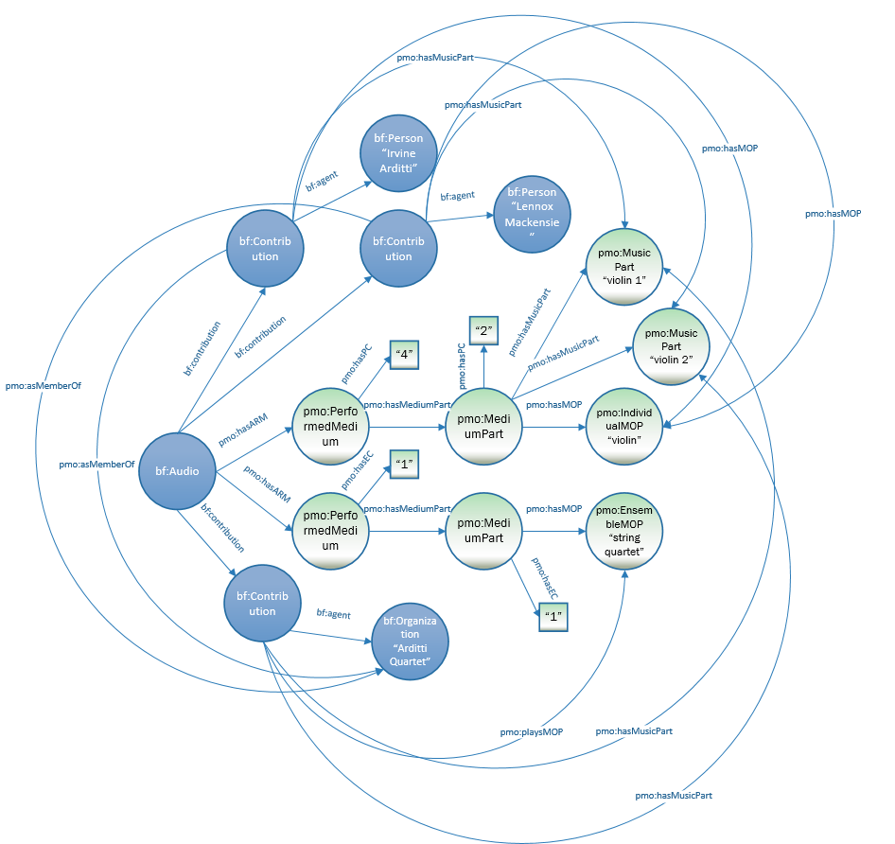

:a1 a bf:Audio ;
pmo:hasMedium [
a pmo:PerformedMedium ;
pmo:hasEnsembleCount “1” ;
pmo:hasMediumPart [
a pmo:MediumPart ;
pmo:hasEnsembleCount "1" ;
pmo:hasDistinctPartCount "4" ;
pmo:hasPerformerCount "4" ;
pmo:hasMediumOfPerformance <http://libraries.stanford.edu/data/stringquartet> ;
pmo:hasMedium [
a pmo:PerformedMedium ;
pmo:hasDistinctPartCount “4” ;
pmo:hasPerformerCount "4" ;
pmo:hasMediumPart [
a pmo:MediumPart ;
pmo:hasDistinctPartCount "2" ;
pmo:hasMediumOfPerformance <http://id.loc.gov/authorities/performanceMediums/mp2013015782> ;
pmo:hasMusicPart [
a pmo:MusicPart ;
rdfs:label "Violin 1" ] ;
pmo:hasMusicPart [
a pmo:MusicPart ;
rdfs:label "Violin 2" ] ;
] ;
] .
bf:contribution [
a bf:Contribution ;
bf:role <http://id.loc.gov/vocabulary/relators/prf> ;
bf:agent <http://id.loc.gov/rwo/agents/n80147597> ;
pmo:hasMediumOfPerformance <http://libraries.stanford.edu/data/stringquartet> ;
] .
bf:contribution [
a bf:Contribution ;
bf:role <http://id.loc.gov/vocabulary/relators/prf> ;
bf:agent <http://id.loc.gov/rwo/agents/n82155189> ;
pmo:hasMediumOfPerformance <http://id.loc.gov/authorities/performanceMediums/mp2013015782> ;
pmo:hasMusicPart [
a pmo:MusicPart ;
rdfs:label "Violin 1" ] ;
pmo:asMemberOf <http://id.loc.gov/rwo/agents/n80147597> ;
] .
bf:contribution [
a bf:Contribution ;
bf:role <http://id.loc.gov/vocabulary/relators/prf> ;
bf:agent <http://libraries.stanford/edu/data/lennoxmackensie> ;
pmo:hasMediumOfPerformance <http://id.loc.gov/authorities/performanceMediums/mp2013015782> ;
pmo:hasMusicPart pmo:hasMusicPart [
a pmo:MusicPart ;
rdfs:label "Violin 2" ;
pmo:asMemberOf <http://id.loc.gov/rwo/agents/n80147597> ;
] .

<http://libraries.stanford.edu/data/stringquartet> a pmo:EnsembleMediumOfPerformance ;
rdfs:label "string quartet" .

<http://id.loc.gov/authorities/performanceMediums/mp2013015782> a bf:Role ;
rdfs:label "performer" .

<http://id.loc.gov/rwo/agents/n80147597> a bf:Organization ;
rdfs:label "Arditti Quartet" .

<http://id.loc.gov/rwo/agents/n82155189> a bf:Person ;
rdfs:label "Arditti, Irvine" .

<http://id.loc.gov/authorities/performanceMediums/mp2013015782> a pmo:IndividualMediumOfPerformance ;
rdfs:label "violin" .

<http://libraries.stanford/edu/data/lennoxmackensie> a bf:Person ;
rdfs:label "Mackensie, Lennox" .

It is possible to associate the performers with mediums of performance, even without formally stating the pmo:PerformedMedium, since the medium of performance is reached both through pmo:PerformedMedium and bf:Contribution. It would look something like this:

Or, to make the diagram clearer:

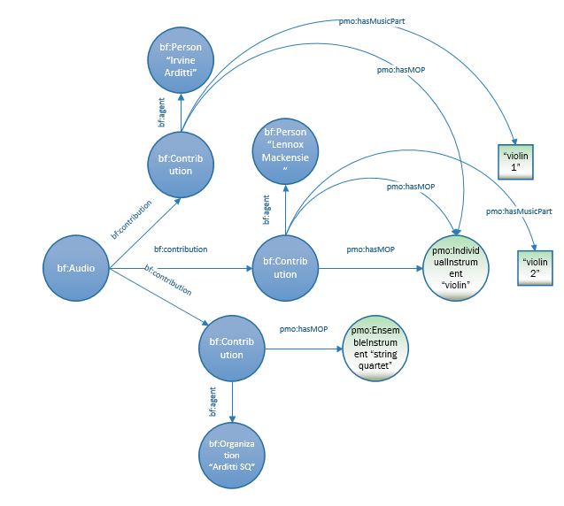

This may be sufficient for a large portion of sound recording cataloging.

:a1 a bf:Audio ;
bf:contribution [
a bf:Contribution ;
bf:role <http://id.loc.gov/vocabulary/relators/prf> ;
bf:agent <http://id.loc.gov/rwo/agents/n80147597> ;
pmo:hasMediumOfPerformance <http://libraries.stanford.edu/data/stringquartet> ;
] .
bf:contribution [
a bf:Contribution ;
bf:role <http://id.loc.gov/vocabulary/relators/prf> ;
bf:agent <http://id.loc.gov/rwo/agents/n82155189> ;
pmo:hasMediumOfPerformance <http://id.loc.gov/authorities/performanceMediums/mp2013015782> ;
pmo:hasMusicPart [
a pmo:MusicPart ;
rdfs:label "Violin 1" ] ;
pmo:asMemberOf <http://id.loc.gov/rwo/agents/n80147597> ;
] .
bf:contribution [
a bf:Contribution ;
bf:role <http://id.loc.gov/vocabulary/relators/prf> ;
bf:agent <http://libraries.stanford/edu/data/lennoxmackensie> ;
pmo:hasMediumOfPerformance <http://id.loc.gov/authorities/performanceMediums/mp2013015782> ;
pmo:hasMusicPart pmo:hasMusicPart [
a pmo:MusicPart ;
rdfs:label "Violin 2" ;
pmo:asMemberOf <http://id.loc.gov/rwo/agents/n80147597> ;
] .

<http://libraries.stanford.edu/data/stringquartet> a pmo:EnsembleMediumOfPerformance ;
rdfs:label "string quartet" .

<http://id.loc.gov/authorities/performanceMediums/mp2013015782> a bf:Role ;
rdfs:label "performer" .

<http://id.loc.gov/rwo/agents/n80147597> a bf:Organization ;
rdfs:label "Arditti Quartet" .

<http://id.loc.gov/rwo/agents/n82155189> a bf:Person ;
rdfs:label "Arditti, Irvine" .

<http://id.loc.gov/authorities/performanceMediums/mp2013015782> a pmo:IndividualMediumOfPerformance ;
rdfs:label "violin" .

<http://libraries.stanford/edu/data/lennoxmackensie> a bf:Person ;
rdfs:label "Mackensie, Lennox" .

