Medium of Performance. Part 2

The document Medium of Performance, Part 1 covered the basic model of medium of performance in PMO. Part 2 extends and refines that model.

Modeling Alternate Mediums of Performance
Some music works offer flexibility in the make up of performing forces, either stating alternates for an individual instrument (e.g., “for violin or flute”) or for the whole medium (“for string quartet or string orchestra”). The option only applies to a pmo:DeclaredMedium, since by the time there is pmo:PerformedMedium, a choice has been made for one option or the other.
For now, PMO has opted to model this in the most basic way possible—by declaring two separate pmo:DeclaredMediums, each with the entire medium for each option. This does mean repetition, but avoids complexity of modeling. Potentially, one might add a single property—pmo:alternateOf—a symmetrical property that links the mediums, but for now, it is not part of the ontology.
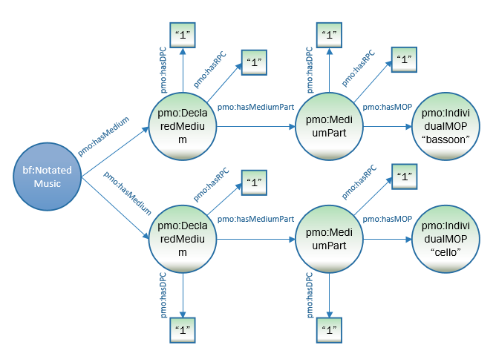

:a1 a bf:NotatedMusic ;

pmo:hasMedium [

a pmo:DeclaredMedium ;
pmo:hasDistinctPartCount “1” ;
pmo:hasRequiredPerformerCount “1” ;

pmo:hasMediumPart [

a pmo:MediumPart ;

pmo:hasDistinctPartCount “1” ;
pmo:hasRequiredPerformerCount “1” ;

pmo:hasMediumOfPerformance <http://id.loc.gov/authorities/performanceMediums/mp2013015074> ] ;

] ;

pmo:hasMedium [

a pmo:DeclaredMedium ;

pmo:hasMediumPart [

a pmo:MediumPart ;

pmo:hasDistinctPartCount “1” ;
pmo:hasRequiredPerformerCount “1” ;

pmo:hasMediumOfPerformance <http://id.loc.gov/authorities/performanceMediums/mp2013015120> ] ;

] .

<http://id.loc.gov/authorities/performanceMediums/mp2013015074> a pmo:IndividualMediumOfPerformance ;

rdfs:label "bassoon" .

<http://id.loc.gov/authorities/performanceMediums/mp2013015120> a pmo:IndividualMediumOfPerformance ;

rdfs:label "cello" .

Modeling Alternate Representations of Ensembles
Sometimes there is a need or desire to model ensembles, especially smaller ones, as both the ensemble as a whole and by its constituent parts (e.g., a string quartet), so that a searcher can discover the work, whether they are looking for a string quartet or for any work that contains 2 violins (or other component). Ideally, the vocabulary used to provide values for pmo:MediumOfPerformance will already model components of stable small ensembles such as string quartets. Wikidata is an example of a vocabulary that does this (see https://www.wikidata.org/wiki/Q207338), though, unlike PMO it models ensembles as groups of people rather than instruments. LCMPT, a medium of performance vocabulary used by catalogers, is unable to model these components at this time. Also the components of most small ensembles are not stable (for instance a jazz combo is defined as “A small ensemble associated with jazz that usually consists of 3 to 6 instruments, including piano, bass, drum set, guitar, saxophone, trumpet, percussion, or other instruments”) and thus cannot be modelled with permanent component parts. Until then, the most straight forward way to model alternate representations is simply to treat each as an individual pmo:DeclaredMedium or pmo:PerformedMedium when vocabulary is available.

The following diagram shows the modeling of a pmo:PerformedMedium, with a piano trio modeled both as an ensemble and as its component parts (including count). Note that the vocabulary for “piano trio” does not currently exist; it would have to be added locally. The URI here is a placeholder, not part of any published vocabulary. A pmo:DeclaredMedium for a piano trio would be modeled in the same way. Note the difference in counts between the two representations.

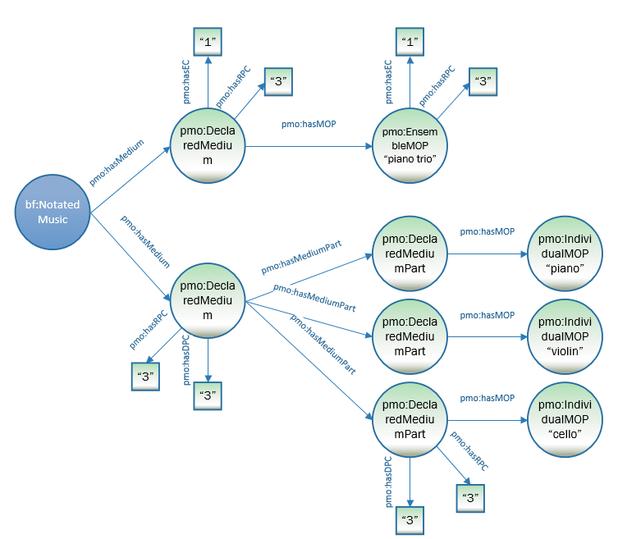
Note: In the lower pmo:DeclaredMedium, each pmo:DeclaredMediumPart has pmo:hasDPC “3” and pmo:hasRPC “3”. They are omitted in the diagram due to space issues.

:a1 a bf:Audio ;
pmo:hasMedium [
a pmo:PerformedMedium ;
pmo:hasEnsembleCount “1” ;
pmo:hasRequiredPerformerCount "3" ;
pmo:hasMediumPart [
a pmo:MediumPart ;
pmo:hasMediumOfPerformance <http://libraries.stanford.edu/data/pianotrio> ;
pmo:hasEnsembleCount "1" ;
pmo:hasRequiredPerformerCount “3” ] ;
] .
pmo:hasMedium [
a pmo:PerformedMedium ;
pmo:hasDistinctPartCount "3" ;
pmo:hasRequiredPerformerCount “3” ;
pmo:hasMediumPart [
a pmo:MediumPart ;
pmo:hasMediumOfPerformance <http://id.loc.gov/authorities/performanceMediums/mp2013015550> ;
pmo:hasDistinctPartCount "1" ;
pmo:hasRequiredPerformerCount “1” ] ;
pmo:hasMediumPart [
a pmo:MediumPart ;
pmo:hasMediumOfPerformance <http://id.loc.gov/authorities/performanceMediums/mp2013015782> ;
pmo:hasDistinctPartCount "1" ;
pmo:hasRequiredPerformerCount “1” ] ;
pmo:hasMediumPart [
a pmo:MediumPart ;
pmo:hasMediumOfPerformance <http://id.loc.gov/authorities/performanceMediums/mp2013015120> ;
pmo:hasDistinctPartCount "1" ;
pmo:hasRequiredPerformerCount “1” ] ;
] .

< http://libraries.stanford.edu/data/pianotrio > a pmo: EnsembleMediumOfPerformance ;
rdfs:label "piano trio" .

<http://id.loc.gov/authorities/performanceMediums/mp2013015550> a pmo:IndividualMediumOfPerformance ;
rdfs:label "piano" .

<http://id.loc.gov/authorities/performanceMediums/mp2013015782> a pmo:IndividualMediumOfPerformance ;
rdfs:label "violin" .

<http://id.loc.gov/authorities/performanceMediums/mp2013015120> a pmo:IndividualMediumOfPerformance ;
rdfs:label "cello" .

Modeling Music Parts
In some cases, a cataloger may want a pmo:MediumPart further subdivided, indicating musical parts (e.g., Violin 1, Clarinet 2), usually to link a specific performer to a specific part. The most obvious example of this might be in the performance of a string quartet, where the roles of the 2 violins are quite different.

Term | Type | Definition
pmo:MusicPart | Class | Specific element within an overall declared or performed medium, e.g., Violin 1, Trumpet 2.

Property | Definition | Domain | Range
pmo:hasMusicPart | The specific music parts within a single medium part e.g., Violin 1, Clarinet 2. | pmo:DeclaredMedium, pmo:PerformedMedium; bf:Contribution (see Part 3) | pmo:MusicPart

The following diagram shows the modeling of the 2 individual parts of a bağlama duet. The pmo:DeclaredMediumPart has a pmo:IndividualMediumOfPerformance with the value “bağlama” and a distinct part count and required performer count each of 2. It also has two pmo:hasMusicPart properties associated with the two parts, Bağlama 1 and Bağlama 2. For joining music parts with performers, see the Medium of Performance, Part 3 paper.

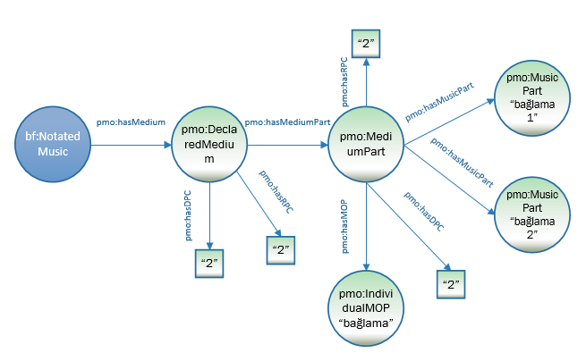
:n1 a bf:NotatedMusic ;
pmo:hasMedium [
a pmo:DeclaredMedium ;
pmo:hasDistinctPartCount “4” ;
pmo:hasMediumPart [
a pmo:MediumPart ;
pmo:hasDistinctPartCount "2" ;
pmo:hasMediumOfPerformance <http://id.loc.gov/authorities/performanceMediums/mp2013015038> ;
pmo:hasMusicPart [a pmo:MusicPart
rdf:value “bağlama 1”] ;
pmo:hasMusicPart [a pmo:MusicPart
rdf:value “bağlama 2” ] ;
] .

<http://id.loc.gov/authorities/performanceMediums/mp2013015038> a pmo:IndividualMediumOfPerformance ;
rdfs:label " bağlama " .

Modeling medium part types
A declared or performed medium part may be labelled as a certain type of part—solo, optional, ad lib, divisi. These are indicated by the property pmo:mediumPartType and the class pmo:MediumPartType.

Class | Definition | Subclass of
pmo:MediumPartType | Specific role or type of a medium part, e.g., solo, ad lib, optional, offstage

Property | Definition | Use with: | Range
pmo:hasMediumPartType | Specific role or type of a medium part, e.g., solo, ad lib, optional, offstage | pmo:DeclaredMedium, pmo:PerformedMedium | pmo:MediumPartType

Four individuals are also provided as values for pmo:hasMediumPartType:
Term | Label | Definition
pmo:solo | solo | For mediums of performance marked "solo" in a score or is clearly a solo part in the context of the work, e.g., a concerto for oboe and orchestra.
pmo:adlib | ad lib (altLabel: ad libitum) | For mediums of performance marked "ad lib" or "ad libitum" in a score or otherwise.
pmo:obligato | obligato | For mediums of performance marked "obligato" in a score or otherwise.
pmo:optional | optional | For mediums of performance marked "optional" in a score or otherwise.
pmo:offstage | offstage | A declared or performed medium that is to be performed or is performed offstage, i.e., out of sight of the audience.

These terms are not intended to be exhaustive of the possibilities, but to provide a basic vocabulary of more commonly encountered terms.

The following diagram models a pmo:PerformedMedium for solo bassoon and orchestra. Note that pmo:DeclaredMedium has both a pmo:IndividualMediumCount (the bassoon) and a pmo:EnsembleCount (the orchestra).
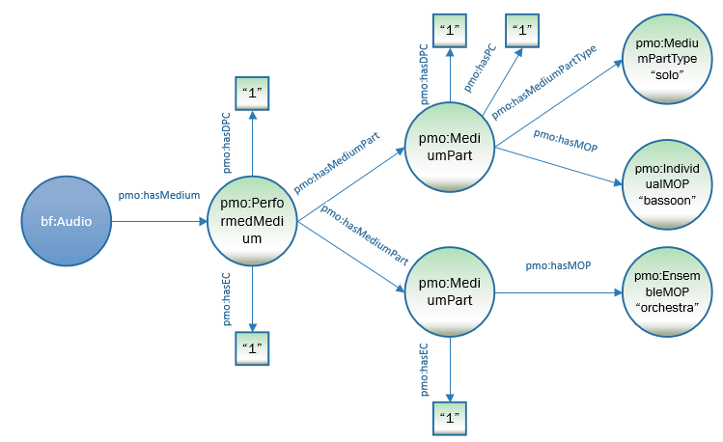

:a1 a bf:NotatedMusic ;

pmo:hasMedium [

a pmo:DeclaredMedium ;
pmo:hasDistinctPartCount “1” ;
pmo:hasEnsembleCount “1” ;

pmo:hasMediumPart [

a pmo:MediumPart ;

pmo:hasDistinctPartCount “1” ;
pmo:hasPerformerCount “1” ;

pmo:hasMediumOfPerformance <http://id.loc.gov/authorities/performanceMediums/mp2013015074> ;

pmo:hasMediumPartType <http://performedmusicontology.org/ontology/solo> ;

] ;

pmo:hasMediumPart [

a pmo:MediumPart ;

pmo:hasEnsembleCount “1” ;

pmo:hasMediumOfPerformance <http://id.loc.gov/authorities/performanceMediums/mp2013015516> ] ;

] .

<http://id.loc.gov/authorities/performanceMediums/mp2013015074> a pmo:IndividualMediumOfPerformance ;

rdfs:label "bassoon" .

<http://id.loc.gov/authorities/performanceMediums/mp2013015516> a pmo:InstrumentEnsemble ;

rdfs:label "orchestra" .

Modeling doubling media

Doubling is the single case in which a pmo:DeclaredMedium or pmo:PerformedMedium may have more than one medium of performance, since the media are conceived as one musical unit.

Property | Subproperty of: | Definition
pmo:hasDoublingMediumOfPerformance | pmo:hasMediumOfperformance | 2 (or more) mediums of performance intended to be performed alternately by a single performer

The following diagram models 2 flutes, 1 of which doubles piccolo.
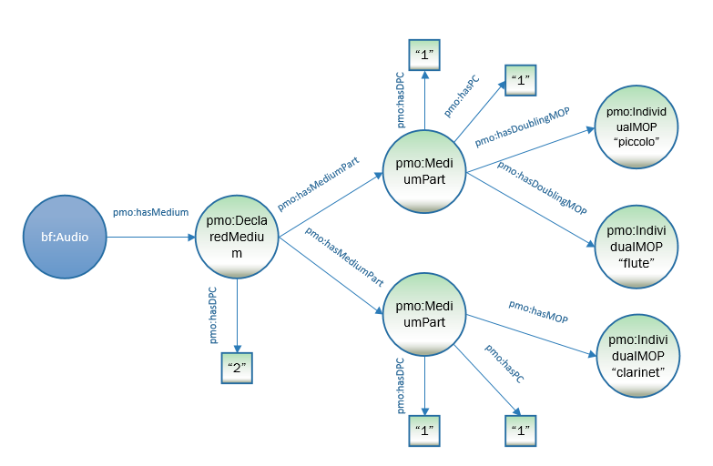
:a1 a bf:NotatedMusic ;
pmo:hasMedium [
a pmo:DeclaredMedium ;
pmo:hasMediumPart [
a pmo:MediumPart ;
pmo:hasDistinctPartCount “1” ;
pmo:hasPerformerCount “1” ;
pmo:hasDoublingMediumOfPerformance <http://id.loc.gov/authorities/performanceMediums/mp2013015268> ;
pmo:hasDoublingMediumOfPerformance <http://id.loc.gov/authorities/performanceMediums/mp2013015553> ;
] ;
pmo:hasMediumPart [
a pmo:MediumPart ;
pmo:hasPerformerCount “1” ;
pmo:hasMediumOfPerformance <http://id.loc.gov/authorities/performanceMediums/mp2013015268> ] ;
] .

<http://id.loc.gov/authorities/performanceMediums/mp2013015268> a pmo:IndividualMediumOfPerformance ;
rdfs:label "flute" .

<http://id.loc.gov/authorities/performanceMediums/mp2013015553> a pmo:IndividualMediumOfPerformance ;
rdfs:label "piccolo" .

