Events

Modeling of Events in BIBFRAME 2.0

BIBFRAME events are discussed in the paper “Event model”. There are two basic relationships between events and works: 1. an event may be the subject of a work; and, 2. an event may have “content” which in BIBFRAME is modelled as a work. A video or recording of an event falls under the second category, as may be seen in the examples below from the Event model paper:
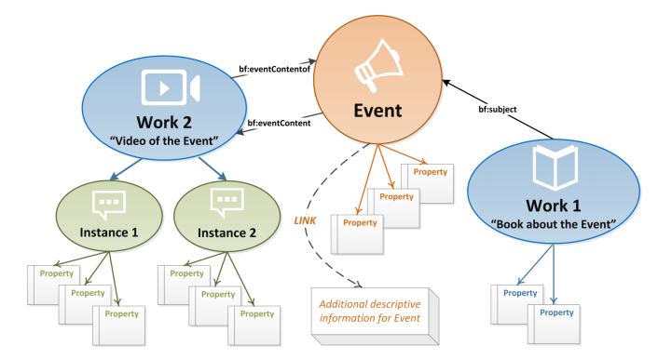

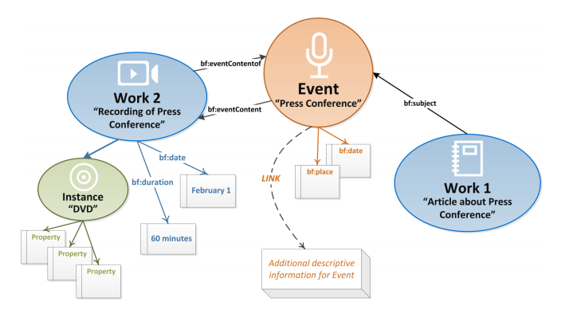
An event may also include multiple sub-events. For example, a concert might have performances of 2 musical works; each of these can be recorded and/or published separately. The concert and 2 works can be modeled as a single event, whose content results in two works as here:

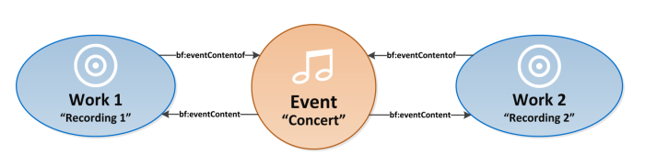
or, the concert and each performance of the individual works that are part of the concert can be modeled as individual events, with the performance events having the relationship of bf:part with the concert event.
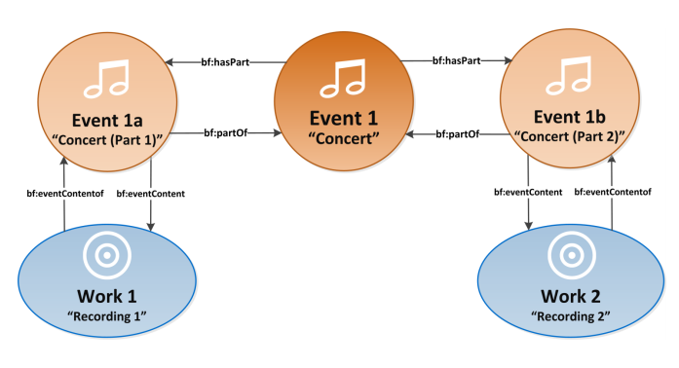
Of these two models, the second is both more semantically logical and provides the ability to describe the individual performances, which may have widely different characteristics. This should be the preferred basic model, though there are probably times when the first must be used because of lack of information or other criteria.
While the diagram does not model the content of the overall event (Event 1) as a work, there is no obvious reason why it could not be considered as such.
The BIBFRAME 2.0 model for a concert is very simple, but is basically sound except in one way—usually the performances (Event 1a, Event 1b) are performances of a pre-existing work. That work is not the same as the work resulting from the recording of the EventContent, here a bf:Audio, which comes into being after or concurrent with the event. This is the case with almost all classical Western music and most popular music. Exceptions include pure improvisations (e.g., Keith Jarrett’s Concert at Köln), and music of some non-Western traditions not based on “the work”.
The BIBFRAME model is also intentionally undeveloped; to be usable, it needs to be subclassed and provided with more specific properties. This is what the PMO extension sets out to do.

Class

Class | subclass of | Definition
Event | rdfs:Resource | Something that happens at a certain time and location, such as a performance, speech, or athletic event, that is documented by a resource.

Properties

Property | Used with | Expected value | Definition
eventContentOf | Work | Event | Event that is the content of the described work.
eventContent | Event | Work | Work whose content is the described event.
hasPart | Work, Instance, or Item | Work, Instance, or Item | Resource that is included either physically or logically in the described source.
partOf | Work, Instance, or Item | Work, Instance, or Item | Resource in which the described resource is physically or logically contained.
subject | Work, Instance, or Item | Resource | Subject term(s) describing a resource

Note that the “Used with” and “Expected value” as given on the BIBFRAME website are only comments in the RDF, not specified domains or ranges. “Event” has not been added to any of them; this oversight needs to be corrected.

Modeling Events in PMO

The BIBFRAME model for event content of music recording is at its most basic, this:
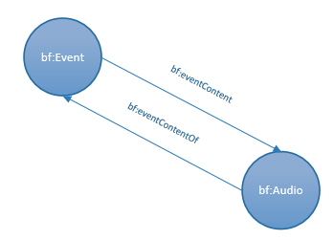
:e1 a bf:Event ;
bf:eventContent :a1 .

:a1 a bf:Audio ;
bf:eventContentOf :e1 .

However, if the bf:Event is a performance of a pre-existing work (such as Beethoven’s 5th Symphony), then in actual fact the bf:Audio is created through the combination of a bf:Event and a bf:Work (generally, the exact instance is not known), not just the event itself. This relationship is not modeled in BIBFRAME. There is also a relationship between the pre-existing bf:Work and the bf:Audio. In FRBR terms, this would be an expression of an expression, and is covered by bf:hasExpression/bf:expressionOf.
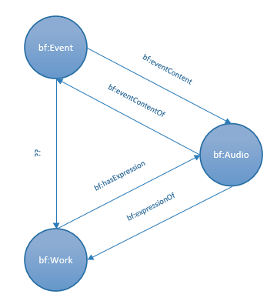

:e1 a bf:Event ;
bf:eventContent :a1 ;
xxx:[undefinedProperty] :w1 .

:a1 a bf:Audio ;
bf:eventContentOf :e1 ;
bf:expressionOf :w1 .
:w1 a bf:Work ;
xxx[undefinedProperty] :e1 ;
bf:hasExpression :a1 .

The properties bf:expressionOf/hasExpression, however, state that they are “[f]or use to connect Works under FRBR/RDA rules. Because of this stated restriction, the property cannot really be used as a generalized link between a performance event and the work that is being performed. Unless LC removes this restriction, another property needs to be created; PMO has chosen pmo:realizedIn/realizationOf.
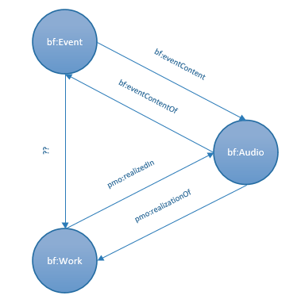

:e1 a bf:Event ;
bf:eventContent :a1 ;
xxx:[undefinedProperty] :w1 .

:a1 a bf:Audio ;
bf:eventContentOf :e1 ;
bf:realizationOf :w1 .
:w1 a bf:Work ;
xxx[undefinedProperty] :e1 ;
bf:realizedIn :a1 .

To make the model more expressive, PMO subclasses bf:Event, in this case the relevant subclass being pmo:Performance. The relationship between the bf:Performance and bf:Audio is expressed through the inverse properties pmo:hasRecording/pmo:recordingOf (subclasses of bf:eventContentOf/ bf:eventContent). The relationship between the bf:Performance and bf:Work is expressed through the inverse property pmo:performanceOf/pmo:hasPerformance.

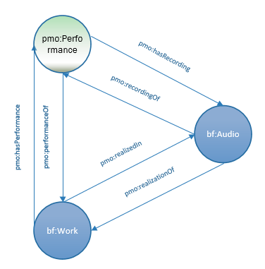
:p1 a pmo:Performance ;
pmo:performanceOf :w1 ;
pmo:hasRecording :a1 .

:w1 a bf:Work ;
pmo:hasPerformance :p1 ;
pmo:realizedIn :a1 .

:a1 a bf:Audio ;
pmo:recordingOf :p1 ;
pmo:realizationOf :w1 .

If there is no pre-existing work before the performance (such as in a fully improvised performance), the bf:Work is excluded.

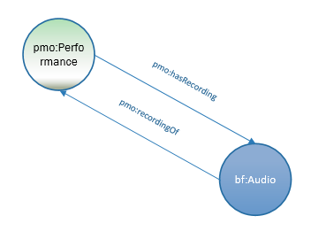
:p1 a pmo:Performance ;
pmo:hasRecording :a1 .

:a1 a bf:Audio ;
pmo:recordingOf :p1 .

Subclasses of bf:Event in PMO

PMO added several subclasses of bf:Event, as listed in the table below. These are not exhaustive and apply primarily to music-related events. In the table, direct subclasses of bf:Event are in bold typeface.

Class | Subclass of | Definition
Audition | bf:Event | Event in which a performer or actor is applying for a position in an ensemble, cast, film, etc.
Ceremony | bf:Event | Ritual event, performed on special occasions (e.g., death, baptism, wedding, graduation, equinox, coronation, victory)
Concert | bf:Event | Live musical performance of one or more works in front of an audience
Benefit Concert | pmo:Concert | Concert held for charitable purposes, i.e., to raise funds or awareness
ConcertSeries | bf:Event | Group of concerts in the same geographic area by a single performer or brought together by a common theme, usually available for sale as a package. e.g., an orchestra concert season, a series featuring chamber ensembles.
ConcertTour | bf:Event | Series of concerts by a performer or group of performers in different cities, countries, or locations.
Festival | bf:Event | Event celebrating communal, religious, or seasonal traditions, creative achievements (i.e., poetry festivals), or food and drink (e.g., wine festivals).
MusicFestival | pmo:Festival | Festival that brings together multiple performers, often lasting for several days.
MasterClass | bf:Event | Event in which a recognized performer critiques the performances of one or more other performers.
Performance | bf:Event | Event in which a performer or group of performers present a work to an audience or in a recording studio.
CommandPerformance | pmo:Performance | Performance done at the request of a monarch or other head of state.
FirstPerformance | pmo:Performance | The world premiere performance of a work.
LivePerformance | pmo:Performance | Performance that is recorded at a concert.
OpenMicPerformance | pmo:LivePerformance | Live performance at a coffee house, night club, or other venue by amateur performers.
RecordingSession | bf:Event | Event in which one or more performances are recorded with the aim of producing a recording for issue.
Rehearsal | bf:Event | Event in which a performer or group of performers prepare for a performance in a concert.

Properties that relate bf:Event to bf:Event or to bf:Work/bf:Audio in PMO

PMO makes use of several BIBFRAME properties in relating events to other classes, but also adds a number of others:

Property | Subproperty of | Domain | Range | Definition
pmo:associatedWith |  | bf:Work | bf:Event | Event that is associated in a general way with a work, instance or item, e.g., the Bible used at a presidential inauguration.
bf:capture |  |  | bf:Capture | Information about place and date associated with the capture (e.g., recording, filming) of the content of a resource.
pmo:createdFor |  | bf:Work | bf:Event | Event for which a particular work, instance, or item was specifically created, e.g., a motet composed for a Florentine wedding in the 16th century.
pmo:recordingOf | bf:eventContentOf | bf:Work | bf:Event | Event content of an audio or video work.
pmo:hasRecording | bf:eventContent | bf:Event | bf:Work | Audio or video work created from the recording of event content.
pmo:performanceOf |  | bf:Event | bf:Work | Work that is realized in a performance.
pmo:hasPerformance |  | bf:Work | bf:Event | Event that is a performance of a work.
pmo:hasTranscription | bf:eventContent | bf:Event | bf:Work | Work created through the transcription in text, music notation, or other manner, of event content.
pmo:transcriptionOf | bf:eventContentOf | bf:Work | bf:Event | Event from which event content is transcribed as text, music notation, or some other manner.
bf:hasPart | bf:relatedTo |  |  | Resource that is included either physically or logically in the described source.
bf:partOf | bf:relatedTo |  |  | Resource in which the described resource is physically or logically contained.
pmo:realizedIn | See Work document
pmo:realizationOf | See Work document

Note: In the web site, bf:hasPart/bf:partOf have expected values of Work, Instance, Item (as does the definition of bf:relatedTo). Since these properties are used in the LC Event paper, PMO is presuming that this is an oversight and bf:Event will be added. Since these are simply comments rather than prescribed domains or ranges in the RDF, it does not affect our modeling.

Diagram of a Recording session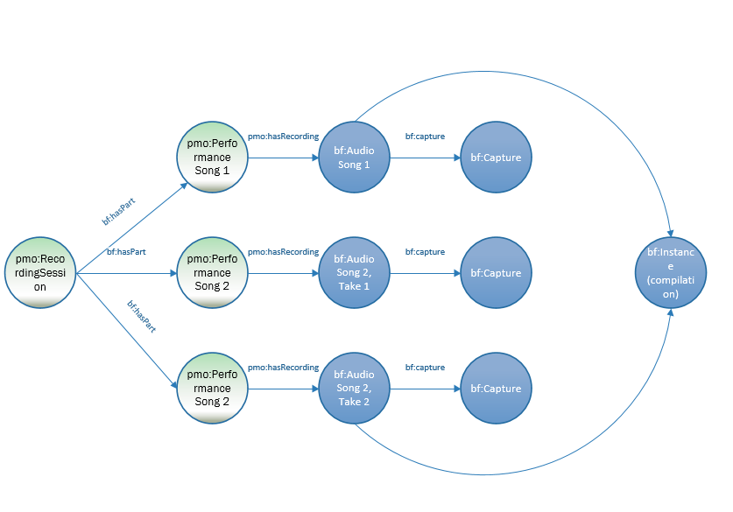

Recording session of two songs, one of which had two takes. Song 1 and Song 2, take 2 later were released. Song 2, take 1 was not released. (This diagram leaves out bf:Work for each performance). A pmo:Concert is modelled much the same. pmo:ConcertTour, pmo:ConcertSeries, pmo:MusicFestival would add another level to the the event.
:e1 a pmo:RecordingSession ;
bf:hasPart :s1 ;
bf:hasPart :s2:1 ;
bf:hasPart :s2:2.

:s1 a pmo:Performance ;
pmo:hasRecording :a1.

:s2:1 a pmo:Performance ;
pmo:hasRecording :a2 .

:s2:2 a pmo:Performance ;
pmo:hasRecording :a3 .

:a1 a bf:Audio ;
bf:capture [
a bf:Capture ] … etc.

Other Classes describing bf:Event

Events are defined as taking place at a certain time and in a certain location. Location may be very specific (a particular recording studio) or broad (“North American tour”). Time will include duration and start/stop times. There may also be a broader time notion of a chronological period (15th century).

Class | Subclass of | Definition
pmo:EventName |  | Name given to an event
bf:Place |  | Geographic location.
bf:Temporal |  | Chronological period

Other Properties describing bf:Event

Property | Subproperty of | Domain | Range | Definition (PMO)
bf:date |  |  | data property
bf:duration |  |  | data property | Information about playing time, running time, etc. of a resource.

bf:Contribution, pmo:PerformedMedium, pmo:DeclaredMedium

A performed music event also has contributors and the mediums (usually musical instruments) on which they perform. Some contributors may be associated only with the event itself (the person who organized a concert tour); others, as with most performers, will be associated both with the event and the recording. Further modeling of these aspects of a performance and their modeling can be found in the Medium of Performance paper [not yet available].

Using the Time Ontology in PMO

BIBFRAME provides datatype properties for date (bf:date) and duration (bf:duration), and a class for a chronological period (bf:Temporal). There is no way of indicating start or stop times. Rather than create new properties within PMO, we suggest using the W3C Time Ontology. This can be used just for stop and start times, or also replace bf:date and/or bf:duration. The classes and properties most likely to be used for events are:

Class | Subclass of | Definition
time:TemporalEntity | owl:Class | A temporal interval or instant.
time:Instant | time:TemporalEntity | A temporal entity with zero extent or duration
time:Interval | time:TemporalEntity | A temporal entity with an extent or duration.
time:Duration | owl:Class | Duration of a temporal extent expressed as a number scaled by a temporal unit

Property | Domain | Range | Definition (PMO)
time:hasBeginning | time:TemporalEntity | time:Instant | Beginning of a temporal entity
time:hasEnd | time:TemporalEntity | time:Instant | End of a temporal entity
time:hasDuration | time:TemporalEntity | time:Duration | Duration of a temporal entity, expressed as a scaled value or nominal value

time:DateTimeDescription may also be useful to those wanting a highly parsed date/time structure.

Connecting to other Music-domain ontologies with Event models

Two other music-domain ontologies (Doremus and the Music Ontology) also have event structures, both of which are more precise and more capable of very fine description of a musical event, particularly recording sessions and related events. Given the generally low level attention given to events in traditional cataloging, the resulting lack of rich information, and a realistic assessment of how much more work a cataloger might be willing or able to provide, PMO has attempted to provide a model, which while richer than what is possible in MARC, does not seek to cover all possibilities. Instead, we made certain our model was as compatible as possible with those of Doremus and the Music Ontology and looked to create a formal link between PMO and Doremus.
The diagram below shows two possible areas to create a link (for all three ontologies, though we have decided just to link to Doremus)—at the class :Performance within the event structure itself; or at the expression level (mo:Recording, mus:Recording, bf:Audio). We felt it best to stay within the event structure, and in particular, the part we created, and so have formally made pmo:Performance a subclass of the FRBRoo class frbr:Performance as used in Doremus. In this way, a cataloger can move beyond the limits of the PMO event structure into the more richly modeled Doremus/FRBRoo structure.

Comparison and alignment: Performed Music Ontology (BF); Music Ontology (FRBR; Event); Doremus (FRBRoo)

An issue has been logged in GitHub to request a change in definition.

