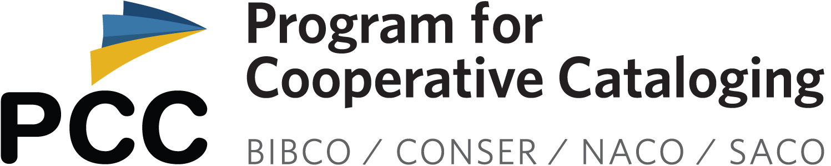
PCC At Large Virtual Conference
Wednesday, April 23rd and Thursday, April 24th, 2025
11 am - 3 pm EST each day

Zoom link: https://loc.zoomgov.com/j/1617635098

All are welcome to attend this virtual meeting. The meeting will be recorded.
Please feel free to log in 10 minutes earlier to test connections or say hi to our colleagues.
PCC Code of Conduct

DAY 1
Link to recording
Passcode: %s2!X=aD

11-11:10
Opening Remarks (MJ Han, University of Illinois Urbana-Champaign, Mingyan Li, University of Illinois, MacKenzie Smith, University of Georgia) (10 minutes)

11:10-12:10
Not the Same old Song and Dance, or, Updates from the NACO Choreographic Work Project (Janice Bunker, Brigham Young University) (60 minutes)

12:10-12:35
Problems with the Removal of $v (Form Subdivisions) in "Modern MARC" (Deborah Tomaras, Marist University) (25 minutes)

12:35-1:35
Lunch break (1 hour)

1:35-2:05
South Asia SACO Funnel (Paromita Biswas, University of California, Los Angeles & Lana Soglasnova, University of Toronto) (30 minutes)

2:05-2:15
Break (10 minutes)

2:15-3:00
PCC SCS Task Group on Privacy in Name Authority Records (Ben Abrahamse, MIT) (45 minutes)

DAY 2
Link to recording
Passcode: mF1sv@.O

11:00-11:35
Derussification and Reparative Cataloging of Music from the Margins of the Soviet Union (Laikin Dantchenko & Jack Haig Nighan, Indiana University) (35 minutes)

11:35-12:15
AI and Organization of Information: Bridging Tradition and Innovation (Magda El-Sherbini, The Ohio State University) (40 minutes)

12:15-1:15
Lunch break (1 hour)

1:15-1:30
Updates from the Core Faceted Subject Access Interest Group (Andrea Schuba, University of Maryland) (15 minutes)

1:30-1:45
Transforming MARC for a Linked Data Age (Lihong Zhu, Washington State University & Sai Deng, University of Central Florida) (15 minutes)

1:45-2:05
Break (20 minutes)

2:05-3:00
Wrap-up & discussion of Standing Committee on Membership and Programming (SCMP) (55 minutes)

